The Specification of Communication Dynamic Library Interface of Pick-to-light™ in PTL System

Overview
The Pick-to-Light(PTL) is consists of ARIS Suite package software, X-Gate controller, X-IOPort Scanner linker, 600U screen, 700U tower light, 800U touch buttons with indicator, 900U pick to light modules; The X-Gate controller connect to the upper computer system through the Ethernet port and down to various devices through bus ports, includes X-IOPort, 600U equipment, 800U equipment, 900U equipment on PTL system, while scanner and 700U tower light access to the buses through X-IOPort, system architecture and installation are as follows:
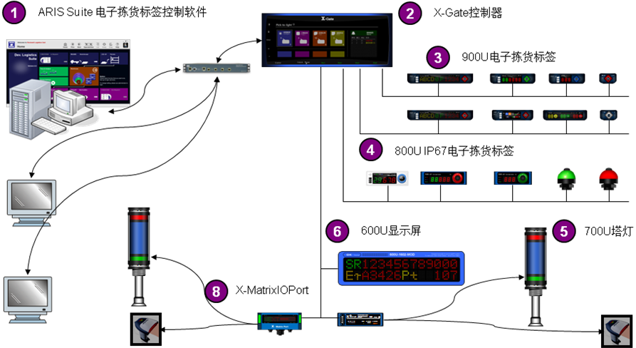
（System architecture）
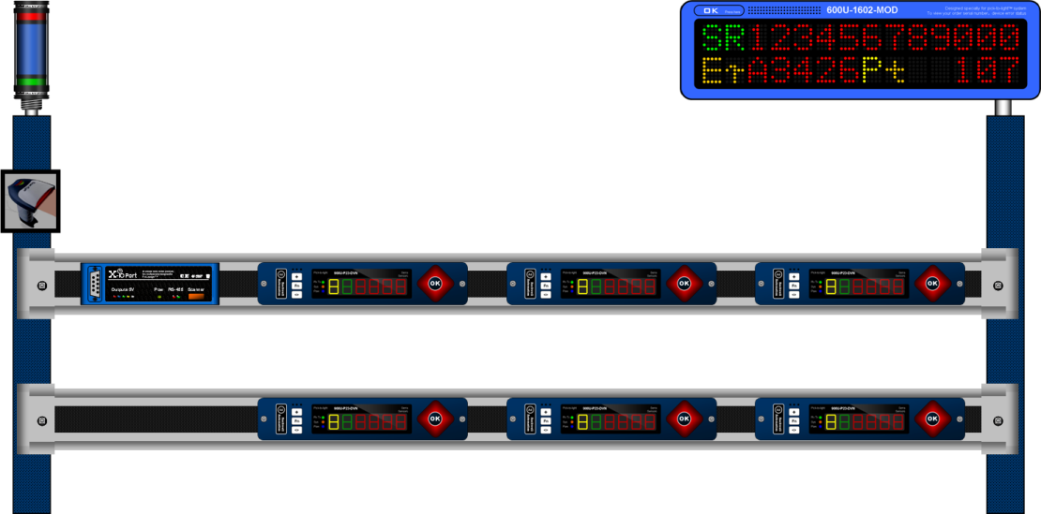
（Installation）
“900U” Represents PTL modules,
“800U” Represents touch buttons
“700U” Represents Tower lights
“600U” Represents led screen
“Tera” means Smart SMT shelf, please ignore it if didn’t buy

The Specification of interface development
The PTL system provides two kinds of interface development modes, as shown in the following:
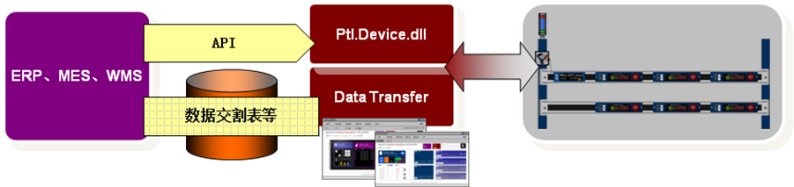
（Interface development modes）

- The API transfer based on dynamic library of communication
ARIS PTL provides the NET dynamic library, which is the bottom communication that interacts directly with devices; application developers can flexibly invoke device control methods according to their own business scenarios to handle device callback events or errors.
Idiographic invoking process see section three dynamic library invoke instruction.

- Development of interface based on data transfer end
ARIS Suite implements a typical business plan for PTL, system such as EPR, MES and WMS can be implemented by custom interface, sending the required job data to ARIS PTL, and the PTL system will send the actual picking information back when the job is finished.
Common interface implementations include database intermediate table, Web Service, RFC, Socket, MQ and etc.
Specific plans won’t be illustrated in this article.

The specification of communication dynamic library invoking
Device communication category library takes XGate, XConverter,XRelay as main entry point to manage all devices connected under it, and XGate is used in most scenarios. And follow the steps below to use the methods provided by the dynamic library.
- Initialize XGate
- Add PTLdevices to the different buses of XGate
- Start unicast communication
- Subscribe to communication mainlines and devices for interactive events and errors
- Light or extinguish all types of PTL indicating equipment
- Handle the callback events of devices

- Functions of XGate and Bus
- Initialize XGate
/// <summary>
/// Initializes the controller using the specified IP, the default port 502, and the bus number 4.
/// </summary>
/// <param name="ip">IP address.</param>
public XGate(string ip);

example:
XGate xgate = new XGate("192.168.0.10");

- Add PTL devices to the different buses of XGate
XGate.Buses[busIndex].Devices.AddOrUpdate(PtlDevice)
/// <summary>
/// add or update devices according to site numbers
/// </summary>
/// <param name="device"> devices that waiting insert</param>
/// <exception cref="System.ArgumentNullException"> devices is empty</exception>
public void AddOrUpdate(PtlDevice device);

example:
Ptl900U ptl900U = new Ptl900U();
ptl900U.Address = 1;
ptl900U.MinorType = Ptl900UType.P24;

xgate.Buses[0].Devices.AddOrUpdate(ptl900U);

- Start unicast communication XGate.StartUnicastCommandQueue
/// <summary>
/// Begin executing the protocol queue for all of the devices on your own and on all the buses
/// </summary>
public void StartUnicastCommandQueue();

example:
xgate.StartUnicastCommandQueue();

- Subscribe the callback events and errors
- Subscribe 600U OK button pressed event, Ptl600U.Pressed
/// <summary>
/// the OK button is pressed
/// </summary>
public event EventHandler Pressed;

example:
ptl600U.Pressed += this.ptl600U_Pressed;

- Subscribe 900U OK button pressed event, Ptl900U.Pressed
/// <summary>
/// the OK button is pressed
/// </summary>
public event EventHandler<Ptl900UPressedEventArgs> Pressed;

example:
ptl900U.Pressed += this.ptl900U_Pressed;

- Subscribe scanner get barcode event, Scanner.ScannedBarcode
/// <summary>
/// scanner get the scanning codes
/// </summary>
public event EventHandler<ScannedBarcodeEventArgs> ScannedBarcode;

example:
mxP1O5.Sacnner.ScannedBarcode += this.Scanner_ScannedBarcode;

- Subscribe bus error, ICommunicationClient. ConnectionError
/// <summary>
/// communication connection error event
/// </summary>
event EventHandler<ConnectionErrorEventArgs> ConnectionError;

example:
foreach(RS485Bus bus in xgate.Buses)
bus.CommunicationClient.ConnectionError += this.CommunicationClient_ConnectionError;

- Subscribe device error, PtlDevice.Error
/// <summary>
/// devices error event
/// </summary>
public event EventHandler<PtlDeviceErrorEventArgs> Error;

example:
ptl900U.Error += this.ptl900U_Error;

- Devices control functions
- Display 600U
/// <summary>
/// show specific content
/// </summary>
/// <param name="text">ASCII text</param>
/// <param name="lightColor">button color</param>
public void Display(string text, LightColor lightColor);

- Clear 600U
/// <summary>
/// clear sepecific content
/// </summary>
/// <param name="mode"> clear methods</param>
/// <remarks>
/// recommond using Display(string.Empty, LightColor.Off) instead
/// </remarks>
public void Clear(Clear600UMode mode);

- Display 900U
/// <summary>
/// show sepecific content
/// </summary>
/// <param name="item"> display item</param>
/// <param name="lightColor">button color</param>
public void Display(Display900UItem item, LightColor lightColor);

- Clear 900U
/// <summary>
/// clear out content
/// </summary>
/// <remarks> always invoke ClearCommandQueue() to clear the previous unfinished commision before this</remarks>
public void Clear();

- start or stop scanner acquisition
/// <summary>
/// acquire or set up wheather cllecting sodes is needed or not
/// </summary>
/// <remarks> clear the cached code after collection is sucesssful</remarks>
public bool EnableCollect { get; set; }

- Display 700U
/// <summary>
/// display the lighthouse
/// </summary>
/// <param name="period"> period of light and exinction</param>
/// <param name="ratio"> ratio of light and extinction</param>
public void Display(LightOnOffPeriod period, LightOnOffRatio ratio);

- Clear 700U
/// <summary>
/// Clear the lighthouse
/// </summary>
public void Clear();

- Display Tera
/// <summary>
/// light indicator light
/// </summary>
/// <param name="lightColors"> all indicator light’s colors</param>
public void Display(IList<LightColor> lightColors);

- Clear Tera
/// <summary>
/// exinguish indicator light
/// </summary>
public void Clear();

- Handle callback events
- handle 900U OK button pressed
/// <summary>
/// button of 900U pressed
/// </summary>
/// <param name="sender"> the pressed 900U</param>
/// <param name="e"> carrying actual number of event argument</param>
void ptl900U_Pressed(object sender, Ptl900UPressedEventArgs e)
{
// By default, events are raised by communication threads, in order not to block communication, so use BeginInvoke
this.BeginInvoke(new MethodInvoker(delegate()
{
this.textBoxMessage.AppendText("OK button pressed, return: ");
foreach (KeyValuePair<Display900UItem, ushort> pair in e.ResultByItem)
this.textBoxMessage.AppendText(pair.Value + " ");
this.textBoxMessage.AppendText(Environment.NewLine);
}));
}

Other Sepecification
This document on introducing the invoking process of dynamic library in general, try to get start easily; More detailed classes, properties, methods, enumerations, definitions, and matters need attentions are also required in the <<Ptl.Device.chm>>.

